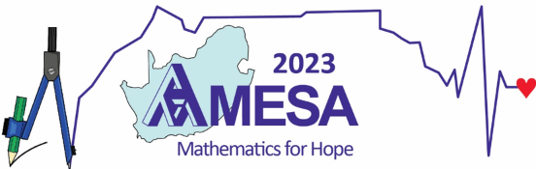 | The Academic Coordinator  Duncan Mhakure  University of Cape Town  Tel: 021 650 5731 (W)  Cell: 083 281 3541  E-mail: duncan@amesa.org.za

PRESENTATION PROPOSAL FORM
This form must be completed and submitted with the full manuscript of your presentation proposal.

DEADLINE: 20 February 2023

You may have to Enable Editing in the warning pop-up:
Click on each °°°°° below and start typing … (To see °°°°° click on in the ribbon/toolbar.)

Type your information, save and then e-mail it with your proposal to the Academic Coordinator.

Format of Presentation (click one only):
Long Paper Short Paper How I teach Poster 1 h Workshop 2 h Workshop
Presentation Categories:
Select your Presentation Categories overleaf to help the Programme Committee to find you an appropriate reviewer
Title of Presentation:

Author(s):

Presenting Author(s):

Contact Details of Presenting Author:
Postal Address:
City:
Postal Code:
Telephone no: Cell no: Fax no:
E-mail:
Only for Long Papers:
If accepted, publish my Long Paper in the AMESA 2023 Proceedings? YES NO
Any other information e.g. equipment requests, limitation in workshop numbers, … :

PTO to select your Presentation Categories

TABLE OF PRESENTATION CATEGORIES

Your proposal will be sent to reviewers according to the categories that you select below.

Educational LEVEL
Click appropriate educational levels:
1. Foundation Phase (Grade R–3) |  | 4. Further Education and Training (FET)
2. Intermediate Phase (Grade 4–6) |  | 5. Teacher Education (pre- & in-service training)
3. Senior Phase (Grade 7–9)

In the case of research, the TYPE of research
Click appropriate types of research:
1. Empirical/ Experimental |  | 4. Ethnographic/Interpretative
2. Statistical |  | 5. Theoretical/Philosophical
3. Case study |  | 6. Action research

Focus THEMES
Click at most four focus themes (note – click again to un-select):
- Indigenous Knowledge Systems |  | 15. Reasoning, proof and proving
2. Financial Mathematics |  | 16. Problem solving and modelling
3. Mathematical Literacy |  | 17. Functions and graphs
4. Teaching and learning of geometry |  | 18. Numeracy
5. Teaching and learning of probability |  | 19. Classroom practice
6. Teaching and learning of algebra |  | 20. Geometrical and spatial thinking
7. Teaching and learning of calculus |  | 21. Measurement, focusing on primary education
8. Teaching and learning of patterns and sequences |  | 22. Mathematics education in a multilingual and multicultural environment
9. Teaching and learning of fractions |  | 23. Mathematics curriculum development
10. Motivation, beliefs and attitudes towards mathematics and its teaching |  | 24. Assessment in mathematics education
11. Mathematical knowledge for teaching |  | 25. Mathematics education at secondary level and access to tertiary level
12. Mathematics in context |  | 26. In-service education, professional development of mathematics teachers
13. Enhancing learner understanding of mathematical concepts |  | 27. Other suitable focus themes (please state here):
14. The use of technology in the teaching and learning of mathematics

