type title here (style is heading 1)
Type the name(s) of the author(s) here, underline the Presenting Author
Type the author(s) institution(s) beneath each name

Type your abstract here, after leaving ONE empty line above. The length may be up to 10 lines. The word “Abstract” is not needed at the beginning of the abstract. The style is italic, no indents, single spacing, which is included in Abstract style.

the main SECTION HEADING (Style is Heading 2)
This is the style Normal. It is 14 point Times New Roman with “at least” 16 point line spacing and automatically provides a 6 pt space after paragraphs.
This is the next paragraph – as you can see, if you use Normal style, you do not have to insert empty paragraphs between paragraphs!

The sub section heading (Style is Heading 3)
The three Heading Styles should be adequate to structure your paper. Please avoid numbering sections (as opposed to lists and footnotes).
Here is an example of a quotation:
If a quotation is more than two lines, it should be put in a separate indented paragraph, as illustrated here. The style is Quote, which is 13 point Times, single spacing, left indented, but not right indented.
Here is an example of a table with its caption:
TABLE 1: Titles of tables. figures, diagrams (Style FigTitle)

Note that the caption for tables is placed above the table, but the caption for figures are placed below the figure.
Here is an example of a transcript in the text (use the Transcript style):
Interviewer: So what did you notice about the relationship?
Elizabeth: One figure is always twice the area of the other.

Use hard page breaks, like this …
Here is an example of references (use the Reference style):
Ball, D.L. (1990). Prospective elementary and secondary teachers’ understanding of division. Journal for Research in Mathematics Education, 21(2), 132-144.
Booth, L.R. (1988). Children’s difficulties in beginning algebra. In A.F. Coxford (Ed.), The ideas of algebra, K-12 (pp. 20-32). Reston, VA: National Council of Teachers of Mathematics.

Page setup
This document has the correct page setup: Size is A4, with margins 2,5 cm top and bottom; 1,7 cm left and right with a gutter of 0,6 cm.

How to use this document
You can work directly in this document – the page setup is correct and you can apply the defined styles to your paragraphs.
Alternatively you can copy the styles in this document to your Normal template:
In Word go Styles window | Manage Styles | Import/Export …
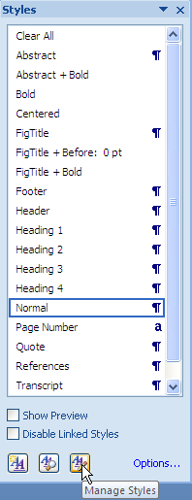
Copy the styles from Styles.docx to Normal.dotm.
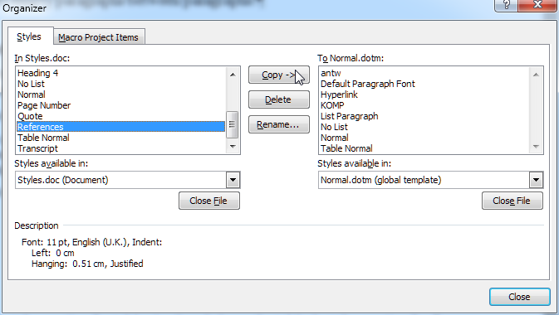
These styles will then be available in any new document.

