Memorabilia Order Form and Provider Contact Details

- Click here for the AMESA 2024 congress Memorabilia Order Form or scan the code

https://forms.office.com/r/3d86A7ZUCZ

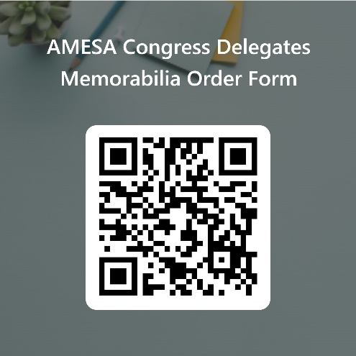

- The Contact Person’s Mobile/WhatsApp number for Memorabilia Queries is 0655564392 or 0659773558.

- Please note that the Order Form will automatically shut down by Midnight on Friday 7 June 2024 and therefore NO orders will be accepted after this date.

